Arm Balance Fundamentals

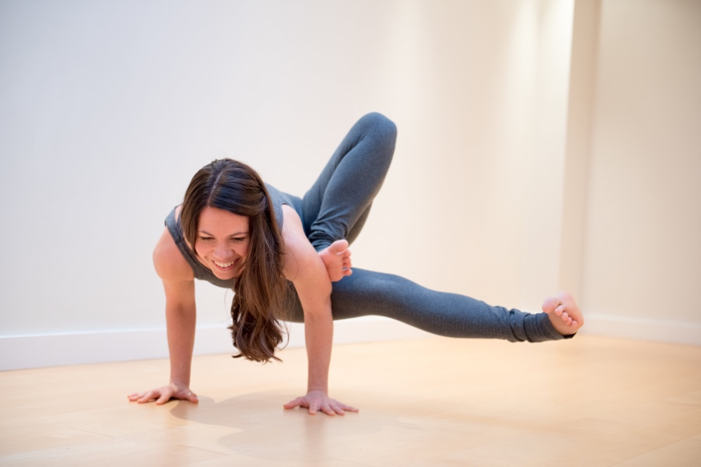

Arm balances are a fun and challenging way to deepen your yoga asana practice. In this extended practice workshop, you will learn tools to help your body prepare for arm balances as well as break down specific poses and how to get into them.

This dynamic and technical workshop will include:
- How to warm up the body for arm balances
- An exploration of what actions and techniques are used to get into the poses
- How to use transitions
- Arm balance postures lab

This practice is open to all levels of practitioners with some experience of yoga.

Saturday June 8th
1.30-3.30pm
£30
@ Space, Brighton

