Saturday 11th May
2-4pm
£25

Deepen Your Practice

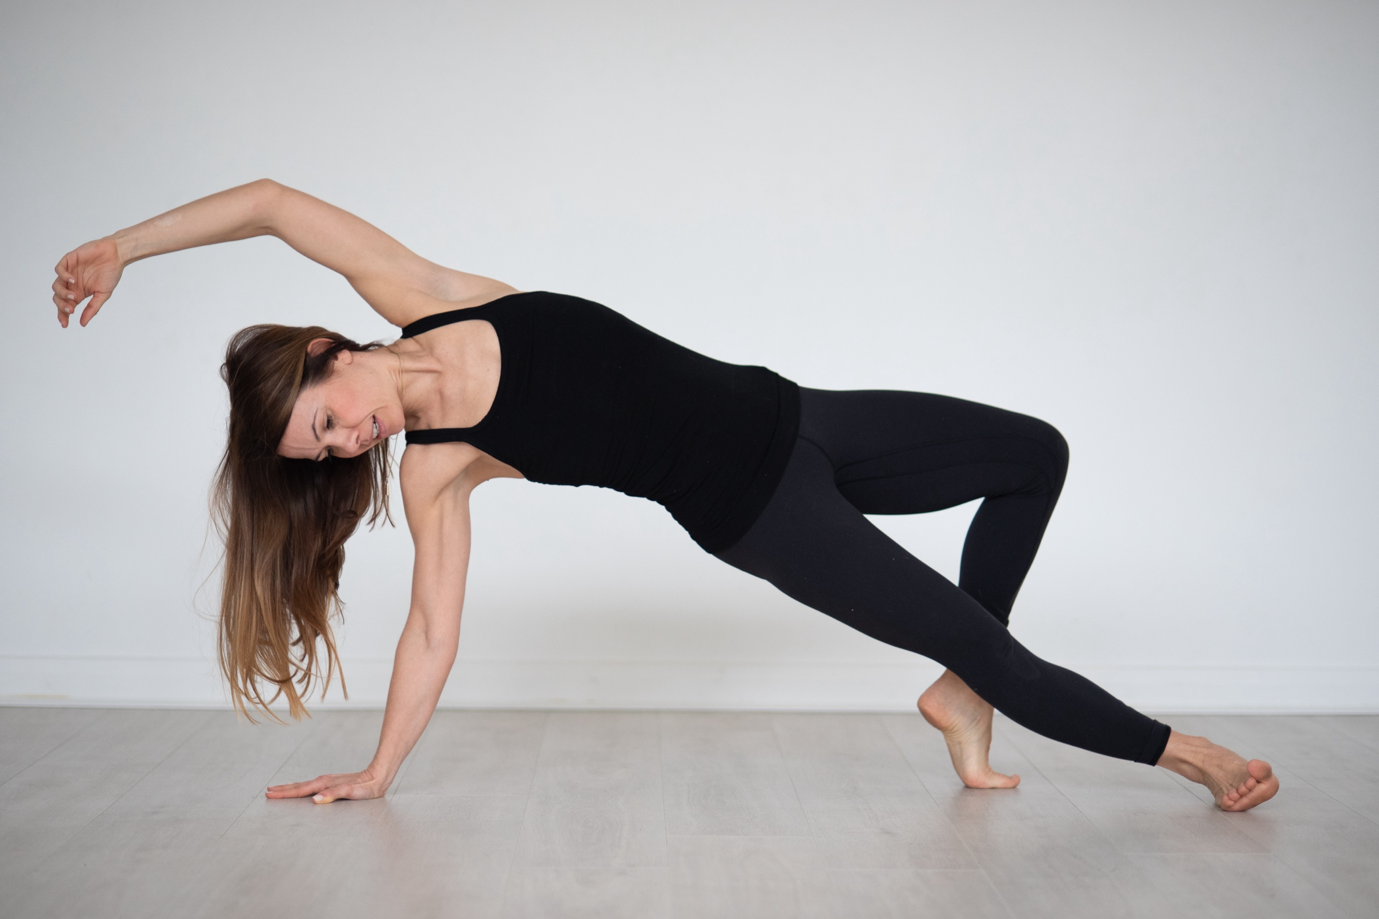

In this dynamic workshop, you will get the opportunity to refine your Vinyasa practice and experience new perspectives on asana. You will explore how to deepen the physical practice in a controlled, safe, and sustainable way without taking away the essence of the practice. This session will encourage you to build a strong, stable foundation for your practice that balances strength and flexibility.

In this workshop you will:
- Break down familiar postures and challenge traditional alignment
- Explore transitions that exploit strength
- Look at advanced poses and how to approach them with confidence
- Learn best practices for avoiding injuries

*This workshop is not suitable for complete beginners.

You can find out more about Sarah at www.sarahwilliamsyoga.com

